Name:

Score: out of

Baldivis Secondary College

Year 11 Mathematics Methods

Test 8 2020

Introduction to Calculus

22

/48
Non-Calculator Section (No calculator, no notes, formula sheet is provided)

Time: 25 minutes Marks: 22 marks

- [2,2,2 = 6 marks]

Find the derivative of the following functions. Express with positive indices.

- y = b) y = c) y =

- [4 marks]

Find the equation of the tangent line to the curve y = at the point (1,2).

- [4 marks]

Using first principles, = , show that the derivative of y = 3x² is 6x.

- [4,1,3 = 8 marks]
Consider the cubic function over the domain -1 ≤ x ≤ 4

- Use calculus techniques to find the location and nature of the stationary points.

- Find the x intercepts

- Graph the function over the given interval

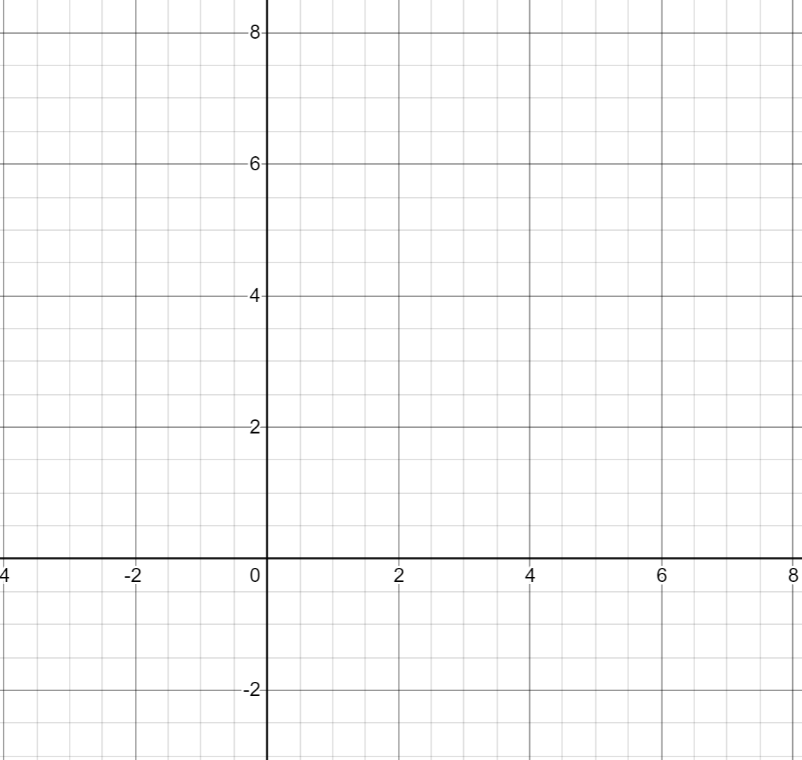

END OF SECTION 1

Baldivis Secondary College

Year 11 Mathematics Methods

Test 8 2020

Introduction to Calculus

Name:

Score: out of

26

Calculator Section (Calculators and 1 page (A4) of notes permitted, formula is sheet provided)

Time: 30 minutes Marks: 26 marks

7. [2, 4, 1 = 7 marks]

- Determine the x-intercepts of the function y = x² – 5x – 24

- Hence, determine the rules for the lines that are tangent to the curve y = x² – 5x – 24 where it crosses the x –axis.

- Find where these tangent lines meet.

8. [1,1,2,2,3 = 9 marks]

A bullet is fired upwards. After t seconds the height of the bullet is found from the rule
H(t) = 150t – 4.9t² + 2 where t is measured in seconds and H in metres.

- Find the height of the bullet after 5 seconds.

The speed of the bullet is the instantaneous rate of change of the height of the bullet.

- Find a rule for the speed of the bullet at any time t.

- Find the speed of the bullet after 5 seconds.

- Find the maximum height of the bullet, to the nearest metre. Indicate your method.

- Determine the bullet’s speed as it hits the ground, on the way down, to 2 decimal places.

9. [1,1,2,2 = 6 marks]

A sketch of f(x) = has been provided below.

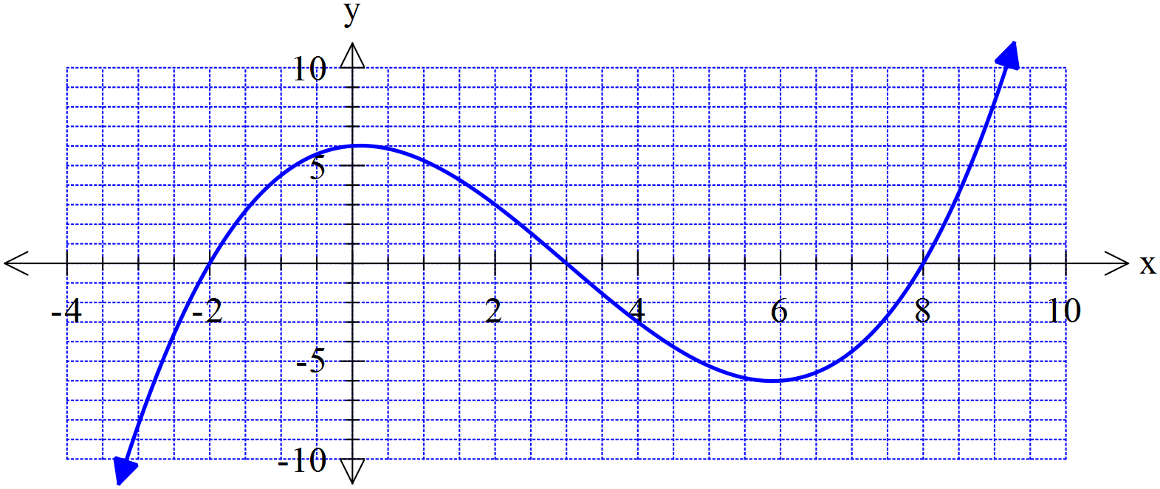

- What is the average (mean) of the two positive roots of f(x)?

- On the graph above sketch a tangent line to the curve for the value of x that you calculated in part (a).

- Find the rule for this tangent line you drew above, that goes through the point where the x-value
Is the average of the two positive roots. You may use your Class Pad.

A student has speculated that the tangent line to the curve at the average of two roots also intersects with the third root.

- Use your answer from part c to show whether this statement is true or false for f(x).
Does this example support the student’s speculation or not? Discuss.

10. [4 marks]

The function y = x³ + ax + b has a local minimum point at (2,3).
Use differentiation to find the values of a and b.

END OF SECTION 2

